LAPORAN PENGERJAAN UJI KOMPETENSI KEJURUAN SMK MAHARDHIKA BATUJAJAR

TAHUN PELAJARAN 2022-2023

KOMPETENSI KEAHLIAN : Rekayasa Perangkat Lunak KELAS : XII Rpl 1

NAMA LENGKAP : Tresna Ramadania

NIS :2021.10.348

PAKET SOAL 2

JENIS APLIKASI : Web

ALOKASI WAKTU : 24 jam

# PENJADWALAN KEGIATAN

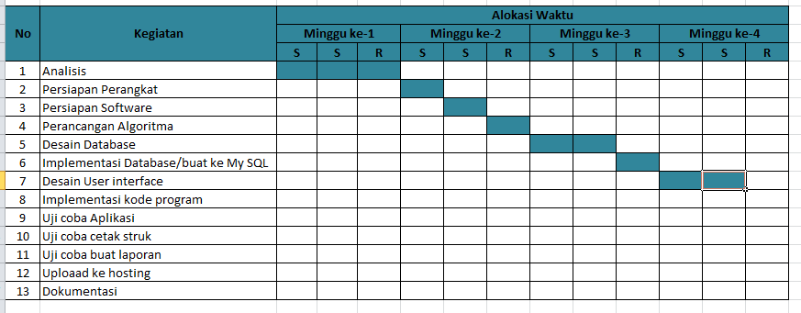

1. **PERSIAPAN PERANGKAT KERAS**

*PC Name : DESKTOP-M4D2CEM*

*Edition : Windows 10 pro*

*Processor : Intel(R) Celeron(R) CPU N3350 @ 1.10GHz 1.10GHz Installed RAM : 2.00 GB (1.87GB usable)*

# PERSIAPAN PERANGKAT LUNAK

*-Xampp Control Panel*

*-Visual Studio Code*

*-Chrome / Firefox*

*-Astah Pro*

*-Balsamiq mockups*

*-Mysql*

*-Microsoft Word*

# PERANCANGAN ALGORITMA APLIKASI

*Silahkan gambarkan activity diagram aplikasi yang kamu buat*

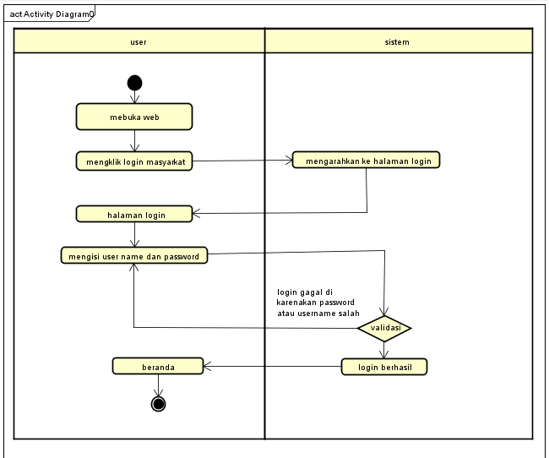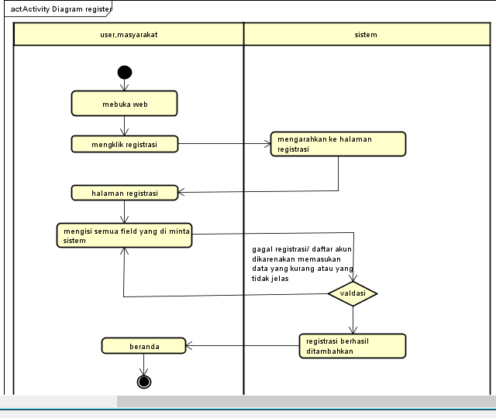

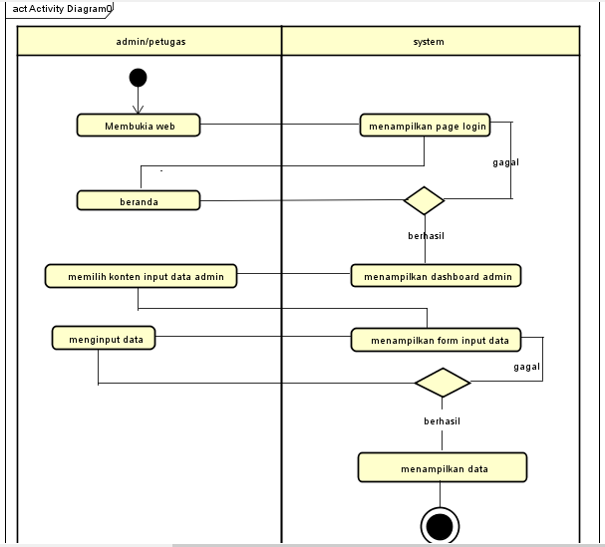

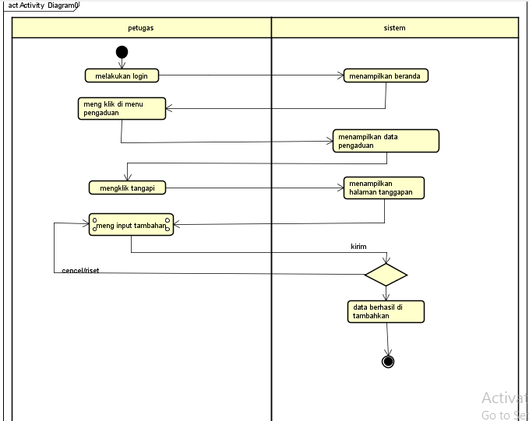

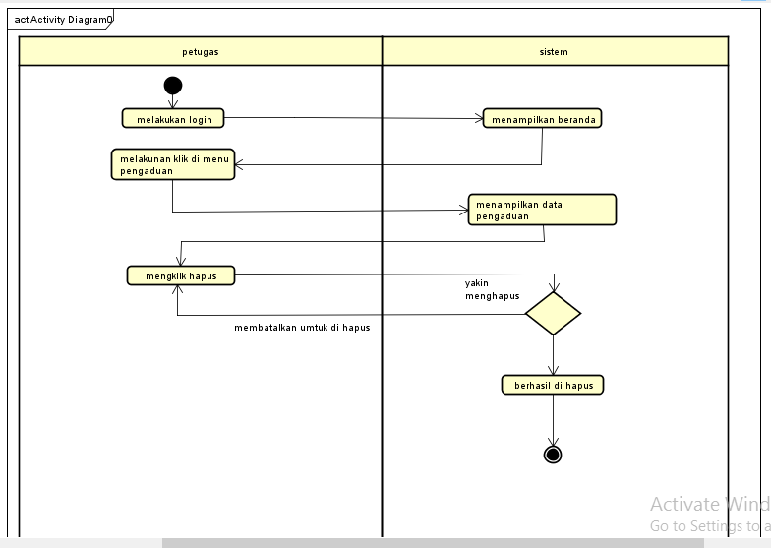

# PERANCANGAN DESAIN BASIS DATA

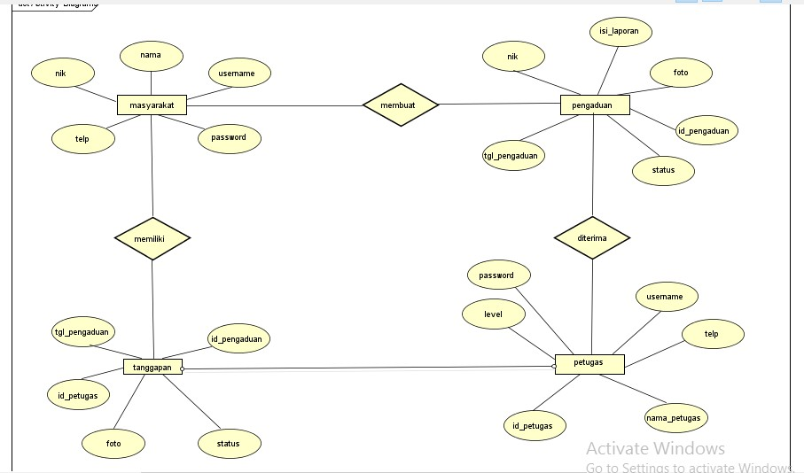*Silahkan gambarkan ERD/DFD/class diagram atau desain basis data pada phpMyAdmin beserta relasinya*

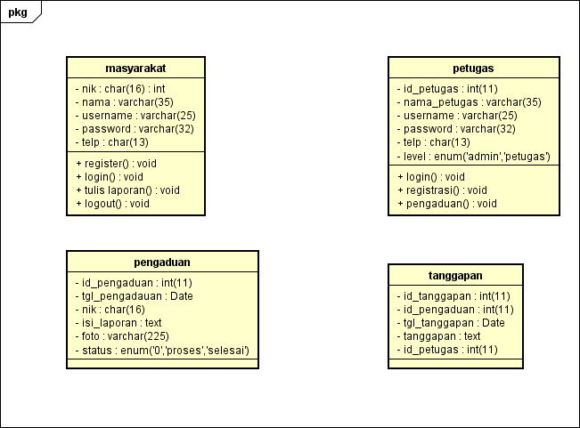

# DUMMY DATA

*Data masyarakat*

|  |  |  |  |  |
| --- | --- | --- | --- | --- |
| *NIK* | *NAMA* | *USERNAME* | *PASSWORD* | *TELEPON* |
| *1234567898765443* | *Zida* | *Zid* | *123* | *089778654321* |
| *1234567898766667* | *Kiara* | *kia* | *432* | *089321654876* |
| *1239876543211234* | *Adam* | *dam* | *111* | *083321123987* |
| *1233210987654321* | *Keanu* | *kean* | *90* | *085432198765* |
| *1234567891011121* | *Qila* | *qiy* | *11* | *089111234789* |

*Data admin*

|  |  |  |  |  |  |
| --- | --- | --- | --- | --- | --- |
| *Id_admin* | *Nama_admin* | *username* | *password* | *Telp_admin* | *level* |
| *1* | *nisa* | *nis* | *14* | *089123456765* | *admin* |
| *12* | *dila* | *dil* | *11* | *085432098765* | *admin* |
| *3* | *erpan* | *Pan* | *10* | *083128765432* | *Admin* |
| *5* | *tresna* | *tres* | *13* | *089765432123* | *admin* |
| *7* | *gyan* | *gyn* | *23* | *082345678909* | *admin* |

*Data petugas*

|  |  |  |  |  |  |
| --- | --- | --- | --- | --- | --- |
| *Id_petugas* | *Nama_petugas* | *username* | *password* | *Telp_petugas* | *level* |
| *9* | *nina* | *nin* | *99* | *089321546789* | *petugas* |
| *2* | *pia* | *pi* | *12* | *087654321098* | *Petugas* |
| *6* | *zizah* | *ziz* | *1* | *089526356209* | *petugas* |
| *8* | *deni* | *den* | *15* | *087321565767* | *Petugas* |
| *4* | *erlan* | *lan* | *17* | *083210989765* | *petugas* |

# PEMBUATAN BASIS DATA (MySQL Code)

*Masyarakat*

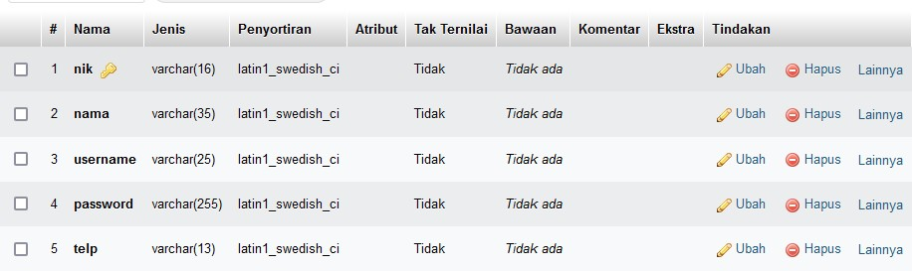

*Pengaduan*

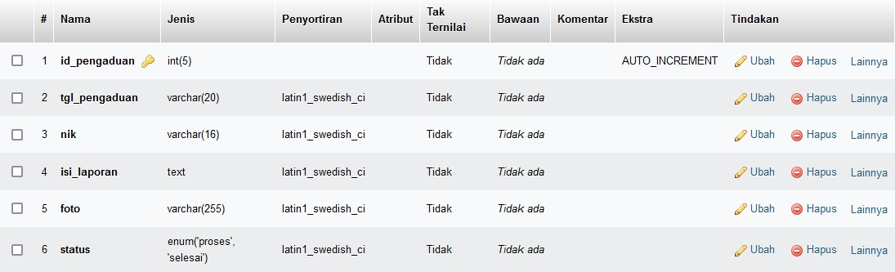

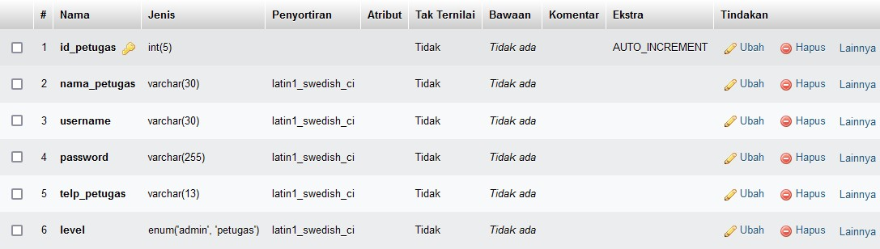*Petugas*

*Tangggapan*

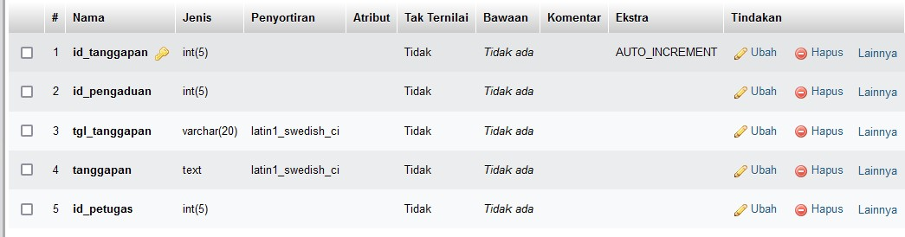

# PERANCANGAN TAMPILAN ANTARMUKA (UI) WEB

* + **Aplikasi pengaduan masyarakat**

1. *Silahkan gambarkan use case diagram aplikasi yang kamu buat*

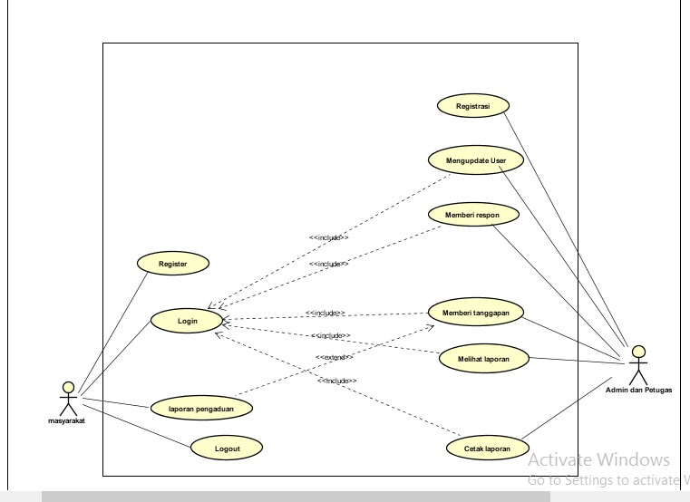

1. Admin dashboard

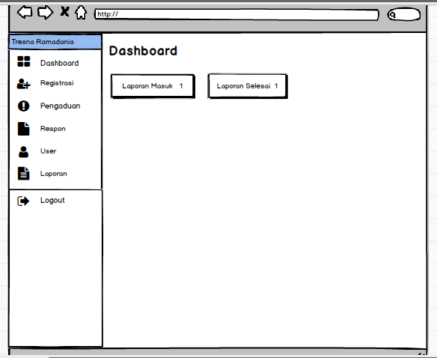

1. Tampilan Petugas

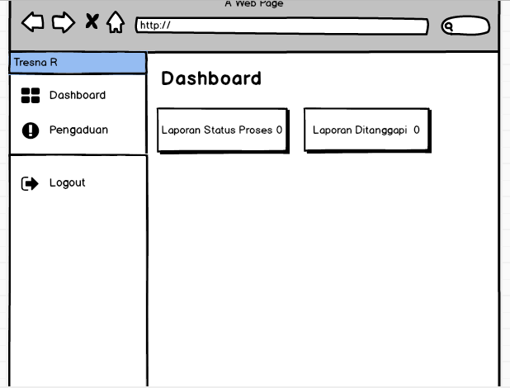

1. Tampilan masyarakat

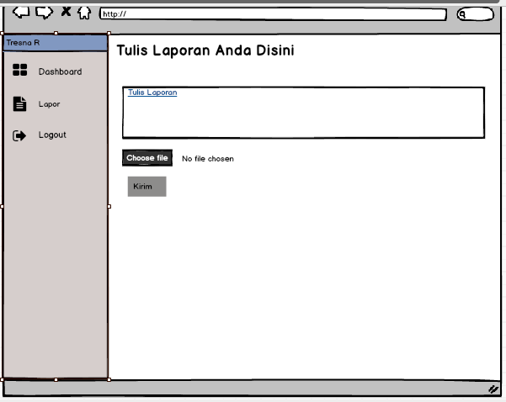

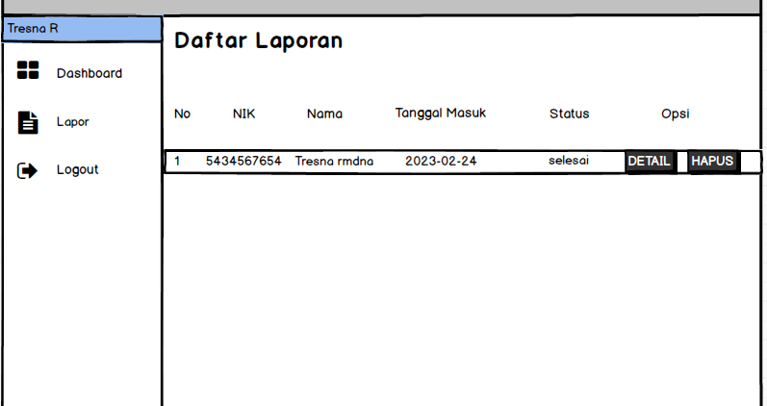

# PEMBUATAN STRUKTUR WEB (HTML)

1. PEMBUATAN STYLE WEB (CSS) File style.css

/* GLOBAL STYLES

*/

/* Padding below the footer and lighter body text */

body {

padding-top: 3rem; padding-bottom: 3rem; color: #5a5a5a;

}

/* CUSTOMIZE THE CAROUSEL

*/

/* Carousel base class */

.carousel {

margin-bottom: 4rem;

}

/* Since positioning the image, we need to help out the caption */

.carousel-caption { bottom: 3rem;

z-index: 10;

}

/* Declare heights because of positioning of img element */

.carousel-item { height: 32rem;

}

/* MARKETING CONTENT

*/

/* Center align the text within the three columns below the carousel */

.marketing .col-lg-4 { margin-bottom: 1.5rem; text-align: center;

}

/* rtl:begin:ignore */

.marketing .col-lg-4 p { margin-right: .75rem; margin-left: .75rem;

}

/* rtl:end:ignore */

/* Featurettes

*/

.featurette-divider {

margin: 5rem 0; /* Space out the Bootstrap <hr> more */

}

/* Thin out the marketing headings */

/* rtl:begin:remove */

.featurette-heading { letter-spacing: -.05rem;

}

/* rtl:end:remove */

/* RESPONSIVE CSS

*/

@media (min-width: 40em) {

/* Bump up size of carousel content */

.carousel-caption p { margin-bottom: 1.25rem; font-size: 1.25rem;

line-height: 1.4;

}

.featurette-heading { font-size: 50px;

}

}

@media (min-width: 62em) {

.featurette-heading { margin-top: 7rem;

}

}

1. PEMBUATAN KODE WEB (PHP/JS) File index.php

<?php session_start(); error_reporting(0);

include '../conn/koneksi.php'; if(!isset($_SESSION['usernam

e'])){

header('location:../index.ph p');

}

elseif($_SESSION['level'] != "masyarakat"){

header('location:../index.ph p');

}

?>

<!DOCTYPE html>

<html>

<head>

<title>Aplikasi Pengaduan masyarakat</title>

<!--Import Google Icon Font-->

<link href="https://fonts.google apis.com/icon?family=Mat erial+Icons" rel="stylesheet">

<!--Import materialize.css--

>

<link type="text/css" rel="stylesheet" href="../css/materialize.mi n.css" media="screen,proj ection"/>

<!-- Compiled and minified CSS -->

<link rel="stylesheet" href="https://cdnjs.cloudfl are.com/ajax/libs/material

ize/1.0.0/css/materialize. min.css">

<!-- Compiled and minified JavaScript -->

<script src="https://cdnjs.cloudfla re.com/ajax/libs/materializ e/1.0.0/js/materialize.min. js"></script>

<script src="https://ajax.googleapi s.com/ajax/libs/jquery/3.4. 1/jquery.min.js"></script>

<!--Let browser know website is optimized for mobile-->

<meta name="viewport" content="width=device- width, initial-scale=1.0"/>

<link rel="stylesheet" type="text/css" href="https://cdn.datatabl es.net/1.10.19/css/jquery. dataTables.css">

<script src="https://ajax.googleapi s.com/ajax/libs/jquery/3.4. 1/jquery.min.js"></script>

<script type="text/javascript" charset="utf8" src="https://cdn.datatable s.net/1.10.19/js/jquery.dat aTables.js"></script>

<script type="text/javascript">

$(document).ready( function () {

$('#example').DataTable(

);

$('select').formSelect();

} );

</script>

</head>

<body style="background:url(../i mg/pnga.png); background-size: cover;">

<div class="row">

<div class="col s12 m3">

<ul id="slide-out" class="sidenav sidenav- fixed">

<li>

<div class="user- view">

<div class="background">

<img src="../img/pnga.png">

</div>

<a href="#name"><span class="black-text name"><b><?php echo ucwords($_SESSION['data'

]['nama']);

?></b></span></a>

</div>

</li>

<li><a href="index.php?p=dashb oard"><i class="material- icons black- text">dashboard</i><b>Da shboard</b></a></li>

<li><a href="index.php?p=lapora n"><i class="material-icons black- text">book</i><b>Lapor</ b></a></li>

<li>

</li>

<li><a class="waves-

effect" href="../index.php?p=logo ut"><i class="material- icons black- text">logout</i><b>Logout

</b></a></li>

</ul>

</div>

<div class="col s12 m9">

<?php if(@$_GET['p']==""){ include_once

'dashboard.php';

}

elseif(@$_GET['p']=="dashb oard"){

include_once 'dashboard.php';

}

elseif(@$_GET['p']=="lapora n"){

include_once 'lapor.php';

}

elseif(@$_GET['p']=="penga duan_hapus"){

$query=mysqli_query($kon eksi,"SELECT * FROM

pengaduan WHERE id_pengaduan='".$_GET['i d_pengaduan']."'");

$data=mysqli_fetch_assoc(

$query); unlink('../img/'.$data['foto']

);

if($data['status']=="proses"

){

$delete=mysqli_query($ko neksi,"DELETE FROM

pengaduan WHERE id_pengaduan='".$_GET['i d_pengaduan']."'"); header('location:index.ph p?p=dashboard');

}

elseif($data['status']=="sele

sai"){

$delete=mysqli_query($ko neksi,"DELETE FROM

pengaduan WHERE id_pengaduan='".$_GET['i d_pengaduan']."'"); if($delete){

$delete2=mysqli_query($ koneksi,"DELETE FROM tanggapan WHERE id_pengaduan='".$_GET['i d_pengaduan']."'");

header('location:index.p hp?p=dashboard');

}

}

}

elseif(@$_GET['p']=="more"

){

include_once 'more.php';

}

?>

</div>

</div>

<!--JavaScript at end of body for optimized loading-->

<script type="text/javascript" src="../js/materialize.min.j s"></script>

<script type="text/javascript" src="https://cdnjs.cloudfla re.com/ajax/libs/materializ e/1.0.0/js/materialize.min. js"></script>

<script type="text/javascript"> document.addEventListen er('DOMContentLoaded', function() {

var elems =

document.querySelectorAl l('.sidenav');

var instances = M.Sidenav.init(elems);

});

document.addEventListen er('DOMContentLoaded', function() {

var elems = document.querySelectorAl l('.modal');

var instances = M.Modal.init(elems);

});

</script>

</body>

</html>

File koneksi.php

<?php $koneksi= mysqli_connect("localhost","root","","db_pengaduan"); ?>

CRUD file

1. UJI COBA

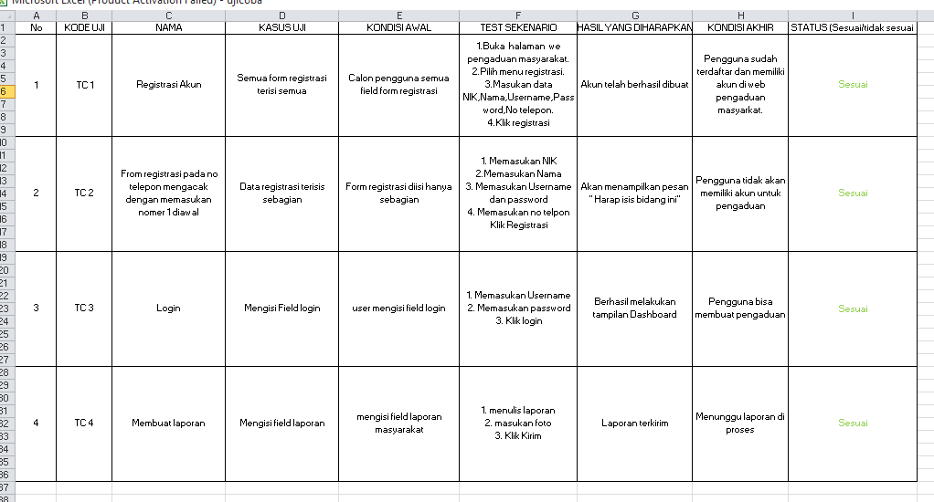

1. REVISI
2. PENENTUAN DOMAIN DAN HOSTING
3. UPLOAD WEB KE HOSTING
4. UPLOAD WEB KE GITHUB
5. PEMBUATAN USER GUIDANCE